Hope & Healing

p

# e

A

C

m

u

m

m

r

S

## August 8th-12th, 9a - 12:30p

Caregivers and kids ages 8 to 12 are invited to Chicago Children’s Advocacy Center’s free Hope & Healing Summer Camp. Through group sessions and activities, we’ll learn how to better support each other and have some fun!

### 9:00 to 10:30

**Group sessions**

**10:30 to 12:30**

**Activity time/Lunch**

Together, we’ll learn about:

* reactions to stress or trauma
* how to identify feelings
* techniques to relax
* problem-solving skills
* positive behavior management

Each day, kids and adults will have a different activity, including:

* making arts and crafts
* playing on the playground
* exploring in the garden
* having time to yourself to relax

**To make a referral, email Rhiannon Reaves:** [**rreaves@chicagocac.org**](mailto:rreaves@chicagocac.org)

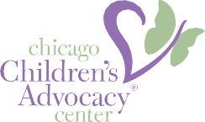

*Transportation is available by request. Child care may be available for kids ages 5 to 7.*

